A project report on

DESIGNING A CRUISE MANAGEMENT AND OBSTACLE DETECTION SYSTEM

Submitted in partial fulfilment for the award of the degree of

MASTER OF COMPUTER APPLICATION
in

Department of Computer Applications
by

SHARUKESH .U 22MCA0196
Under the guidance of Dr.TAPAN KUMAR DAS

School of Computer Science Engineering and Information Systems
VIT Vellore.



DECLARATION

I hereby declare that the thesis entitled “DESIGNING A CRUISE MANAGEMENT AND OBSTACLE DETECTION SYSTEM” submitted by me, for the award of the degree of Specify the name of the degree VIT is a record of bonafide work carried out by me under the supervision of Dr. TAPAN KUMAR DAS
I further declare that the work reported in this thesis has not been submitted and will not be submitted, either in part or in full, for the award of any other degree or diploma in this institute or any other institute or university.

Place:Vellore
Date: Signature of the candidate

:

CERTIFICATE

This is to certify that the thesis entitled “DESIGNING A CRUISE MANAGEMENT AND OBSTACLE DETECTION SYSTEM” submitted by U.SHARUKESH (22MCA0196) Vellore
Institute of Technology, for the award of the degree of Master of Computer Application is a record of bonafide work carried out by him/her under my supervision.
The contents of this report have not been submitted and will not be submitted either in part or in full, for the award of any other degree or diploma in this institute or any other institute or university. The Project report fulfils the requirements and regulations of VIT and in my opinion meets the necessary standards for submission.

Signature of the Guide Signature of the VIT-SCORE-GUIDE

Internal Examiner External Examiner

Head of the Department Department of Computer Application

ACKNOWLEDGEMENTS

It is my pleasure to express with a deep sense of gratitude to my masters thesis guide Dr.TAPAN KUMAR DAS Professor,School of Computer Science Engineering and Information Systems, Vellore Institute of Technology, for his constant guidance, continual encouragement, and understanding; more than all, he taught me patience in my endeavour. My association with him is not confined to academics only, but it is a great opportunity on my part to work with an intellectual and expert in the field of COMPUTER OF APPLICATION.
"I would like to express my heartfelt gratitude to Dr. G Viswanathan, Chancellor; Mr. Sankar Viswanathan, Vice President; Dr. Sekar Viswanathan, Vice President; Dr. G V Selvam, Vice President; Dr. V. S. Kanchana Bhaaskaran, Vice Chancellor; Dr. Partha Sharathi Mallick, Pro- Vice Chancellor; Dr. Jayabarathi T, Registrar and Dr. Sumathy S, Dean of School of Computer Science Engineering and Information Systems, for providing me with an enriching environment to work in and for their inspirational guidance throughout the tenure of the course. "In a jubilant mood, I express ingeniously my whole-hearted thanks to Dr E Vijayan Associate Professor Senior & Head, Department of Computer Applications, MCA Project Coordinator, all teaching staff and members working as limbs of our university for their not-self-centred enthusiasm coupled with timely encouragements showered on me with zeal, which prompted the acquirement of the requisite knowledge to finalize my course study successfully. I would like to thank my parents for their support.
It is indeed a pleasure to thank my friends who persuaded and encouraged me to take up and complete this task. Last, but not least, I express my gratitude and appreciation to all those who have helped me directly or indirectly toward the successful completion of this project.
Place: Vellore

Date: SHARUKESH.U

EXECUTIVE SUMMARY

Cruise control systems represent a cornerstone of automotive technology, offering drivers convenience, comfort, and efficiency during long journeys. This executive summary provides an overview of cruise control systems, their evolution, functionality, benefits, and impact on the automotive industry.Cruise control systems, also known as speed control or autocruise, are electronic systems designed to maintain a steady speed of a vehicle without manual throttle input from the driver. Initially introduced as a luxury feature in high-end vehicles, cruise control has become increasingly prevalent across various car segments, offering drivers a hands-free driving experience on highways and open roads.The development of cruise control technology can be traced back to the early 20th century, with rudimentary systems introduced in experimental vehicles. However, it wasn't until the 1950s and 1960s that cruise control systems began to gain traction in commercial vehicles, primarily in the United States. Early cruise control systems relied on mechanical components to maintain speed, whereas modern systems leverage advanced electronic control units (ECUs), sensors, and actuators for precise speed regulation and adaptive functionality.Cruise control systems operate by allowing the driver to set a desired speed, which the vehicle then maintains automatically. The core components of a cruise control system include a control interface (usually on the steering wheel or dashboard), speed sensors, throttle actuators, and electronic control modules. Depending on the system's sophistication, additional features such as adaptive cruise control (ACC), lane-keeping assist, and stop-and-go functionality may be integrated to enhance safety and convenience.Cruise control systems offer a myriad of benefits to drivers, passengers, and the automotive industry as a whole maintaining a consistent speed, cruise control systems help optimize fuel consumption and reduce emissions, contributing to environmental sustainabilit Long-distance driving can be physically and mentally taxing. Cruise control systems help mitigate driver fatigue by providing consistent speed control and reducing the cognitive load associated with throttle management.Advanced cruise control systems, such as ACC, incorporate collision avoidance features, adaptive braking, and lane-keeping assist to enhance vehicle safety and reduce the risk of accidents.Cruise control systems enhance the overall driving experience by offering a seamless blend of automation and human control, empowering drivers to focus on navigation and situational awareness.The widespread adoption of cruise control systems has had a profound impact on the automotive industry Cruise control has become a standard feature in many vehicles across various price points, driven by consumer demand for convenience and safety.The evolution of cruise control technology has spurred innovation in areas such as sensor fusion, artificial intelligence, and vehicle-to-vehicle communication, paving the way for autonomous driving capabilities.Cruise control systems must adhere to stringent safety regulations and standards, driving continuous improvement in system reliability, robustness, and fail-safe operation.Automakers differentiate their vehicles by offering advanced cruise control features, such as adaptive cruise control, lane-keeping assist, and autonomous driving capabilities, to attract discerning customers and gain a competitive edge in the market.The future of cruise

control systems is poised for further innovation and integration with emerging technologies, such as electrification, connectivity, and autonomous driving. As vehicles evolve into increasingly interconnected and autonomous entities, cruise control systems will play a pivotal role in shaping the future of mobility, offering drivers unparalleled levels of comfort, safety, and efficiency.
ii

CONTENTS

ACKNOWLEDGMENT i
EXECUTIVE SUMMARY ii
LIST OF CONTENTS iii
iii
LIST OF CONTENTS
CHAPTER 1
INTRODUCTION 1
  - OVERVIEW OF CRUIZE CONTROL SYSTEM 2
  - IMPORTANCE OF CRUIZE CONTROL IN MODERN VEHICLES 3
    - Enhanced Driving Comfort 4
    - Improved Fuel Efficiency 5
    - Reduced Driver Fatigue 7
    - Increased Safety 9
    - compilance of with speed. 10
    - Convenience in Trafic 11
    - Assistance for Drivers with Disabilities 12
    - Integration with Advanced Driver Assistance Systems (ADAS) 13
  - OBJECTIVES
    - Maintain Consistent Speed. 14
    - REDUDCED DRIVER WORK 15
    - ENHANCE FUEL EFFICIENCY 16
    - IMPROVE THE SAFETY 17
    - Assist with Speed Compliance 18
    - ENHACE DRIVING COMFORT 19
    - Enable Hands-Free Driving Features
  - SCOPE OF THE PROJECT
    - REQUIREMENT ANALYSIS 20
    - SYSTEM DESIGN 21
    - HARDWARE AND SOFTWARE DEVELOPMENT 22
    - INTEGRATION AND TESTING 23
    - SAFETY AND COMPILANCE 24
    - USER TRAINING AND DOCUMENT 25
    - MAINTANCE AND SUPPORT 26
    - CONTINOUS IMPROVEMENT 27
  - PROPOSED SYSTEM
    - ADVANTAGES OF PROPOSED SYSTEM 28
CHAPTER 2
  - LITERATURE REVIEW
    - BACKGROUND 29
    - LITERATURE REVIEW 30
CHAPTER 3
  - SYSTEM REQUIREMENTS AND SPECIFICATION
    - INTRODUCTION 31
  - ARDUINO IDE SOFT 32
    - INEXPENSIVE 33
    - CROSS PLATFORM 34
    - SIMPLE CLASS PROGRAMMING ENVIRONMENTS 35
    - OPEN SOURCE AND EXTENSIBLE SOFTWARE 36
    - OPEN SOURCE AND EXTENSIBLE HARDWARE 37
CHAPTER 4
  - MODULES
    - ARDUINO UNO. 38
    - UILTRASONIC SENSOR 39
    - JUMPER WIRE 40
    - 16X LCD DISPLAY 41
    - 100 RPM MOTOR 42
    - L293D MOTOR DRIVER MODULE 43
    - BATTERY 45
    - DOT BOARD. 46
    - RF CONTROLLER 47
    - RF RECEIVER 48
CHAPTER 5
  - ARCHITECTURE DIAGRAM 49
  - FLOW DIAGRAM 50
  - USE CASE DIAGRAM 51
  - CLASS DIAGRAM 52
  - SEQUENCE DIAGRAM 53
CHAPTER 6
  - IMPLEMENTATION 54
    - SAMPLE CODE 55
CHAPTER 7
  - CONCLUSION 56
  - FUTURE WORK ENHANCEMENT 58
  - REFERENCES 60

CHAPTER-1 INTRODUCTION

1.1 INTRODUCTION
Introducing the Cruise Control System: Transforming Driving Experience and Safety In the ever- evolving landscape of automotive technology, one innovation stands out as a hallmark of convenience, efficiency, and safety: the cruise control system. This ingenious feature, integrated into modern vehicles, revolutionizes the driving experience by offering drivers a hands-free option for maintaining a constant speed without the need for continuous manual throttle control. Beyond its fundamental purpose of alleviating the monotony of long highway journeys, cruise control represents a paradigm shift in automotive engineering, driven by advancements in sensor technology, electronic control units, and vehicle automation. At its core, the cruise control system embodies the marriage of precision engineering and intelligent automation. By leveraging sophisticated sensors and control algorithms, this system empowers drivers to set a desired speed, allowing the vehicle to autonomously adjust throttle input to maintain that speed, even in varying road and traffic conditions. This capability not only reduces driver fatigue during extended trips but also enhances fuel efficiency by optimizing engine performance and minimizing unnecessary acceleration and deceleration.
However, the significance of cruise control extends far beyond mere convenience. In an era where road safety is of paramount concern, cruise control systems play a pivotal role in enhancing driver awareness and reducing the risk of accidents. By promoting steady and consistent speeds, cruise control helps mitigate the effects of driver distraction and fatigue, factors that contribute significantly to road accidents. Moreover, some advanced cruise control systems incorporate adaptive features that dynamically adjust vehicle speed based on real-time traffic conditions, further enhancing safety and minimizing the likelihood of collisions.The evolution of cruise control systems has been driven by a relentless pursuit of innovation and improvement. From early iterations that simply maintained a constant speed to sophisticated adaptive systems capable of autonomous speed and distance control, cruise control technology has undergone a remarkable transformation. Today, cruise control systems integrate seamlessly with other advanced driver assistance systems (ADAS), such as lane-keeping assist and collision avoidance systems, to provide a comprehensive suite of safety features that enhance driver confidence and peace of mind.

OVERVIEW OF CRUIZE CONTROL SYSTEM
Cruise control is a futuristic feature that enhances driving comfort by maintaining a constant speed. It operates as an electrical system enabling drivers to set their vehicle to a specific speed, freeing them from constantly pressing the accelerator pedal. This not only alleviates foot fatigue and stress

during long drives but also promotes greater fuel efficiency. By cruising at a steady speed instead of accelerating intermittently, vehicles consume less fuel, as rapid acceleration requires more energy, resulting in up to 60% more fuel consumption compared to using cruise control. Embracing cruise control means letting the vehicle autonomously maintain a steady cruising speed, making fuel savings effortless. The forefront of cruise control technology today is adaptive cruise control, a smart system present in nearly all modern vehicles. While conventional cruise control allows setting a desired speed, adaptive cruise control goes further by ensuring a safe distance between your vehicle and the one in front. Utilizing forward-mounted sensors, adaptive cruise control adjusts the vehicle's pace to maintain a consistent distance from the preceding car. If the leading vehicle slows down, the system automatically applies the engine brake to reduce your vehicle's speed while keeping the chosen distance. Many view adaptive cruise control as a precursor to fully autonomous driving, although it does not equate to complete autonomy. Despite its advanced capabilities, drivers must keep their hands on the wheel and remain vigilant of the road while using adaptive cruise control.

IMPORTANCE OF CRUIZE CONTROL IN MODERN VEHICLES
Cruise control is a feature that allows drivers to set a desired speed for their vehicle, which the car then maintains automatically without the need for continuous manual throttle control. Here are some key reasons why cruise control is important in modern vehicles:
    - Enhanced Driving Comfort:The integration of a cruise control system into vehicles not only simplifies driving but also enhances the overall comfort of the driving journey. By enabling drivers to set and uphold a steady speed without continuous manual throttle adjustments, cruise control minimizes the physical strain typically associated with extended periods behind the wheel. This reduction in repetitive foot movements and the constant vigilance required to monitor speed not only diminishes driver fatigue but also boosts overall comfort levels, especially during lengthy trips. Moreover, cruise control fosters a smoother driving experience by maintaining a consistent pace, thereby alleviating the discomfort caused by frequent changes in acceleration and deceleration. Additionally, advanced cruise control functionalities, such as adaptive cruise control, contribute to comfort by automatically regulating vehicle speed to maintain a safe distance from other vehicles, reducing the need for sudden speed alterations and creating a more serene driving ambiance. Ultimately, by relieving drivers of the responsibility of manual speed control and fostering a more uniform and predictable driving atmosphere, cruise control systems play a pivotal role in enhancing the comfort of occupants, rendering long-distance travel more enjoyable and less physically demanding.
    - Improved Fuel Efficiency:Adopting a cruise control system goes beyond mere convenience; it presents a strategic approach to enhancing fuel efficiency while driving. By relying on the system to uphold a constant speed, drivers tap into considerable potential for curbing fuel consumption and extending mileage. The system's capability to manage throttle input meticulously is key, as it minimizes unnecessary speed changes that typically result in fuel wastage. Research confirms that vehicles maintaining a steady pace consume significantly less fuel than those experiencing

frequent fluctuations in speed. This efficiency advantage is particularly pronounced during extended highway trips, where the consistent operation of the cruise control system enables the engine to operate within its most fuel-efficient RPM range consistently. Furthermore, by mitigating the tendency for drivers to overcompensate with throttle adjustments, cruise control contributes to a smoother driving experience, further enhancing fuel efficiency. Ultimately, by leveraging cruise control to sustain a consistent cruising speed, drivers stand to realize substantial improvements in fuel efficiency, translating to savings at the fuel pump and a reduced environmental impact with each mile traveled.
    - Reduced Driver Fatigue:Implementing a cruise control system in vehicles not only offers convenience but also acts as an effective strategy to combat driver fatigue. By enabling drivers to establish and sustain a consistent speed without the need for constant manual throttle adjustments, cruise control helps alleviate the physical and mental strain associated with lengthy drives. This reduction in repetitive foot movements and the requirement to continually monitor speed significantly contributes to mitigating driver fatigue, especially during extended trips on highways. Furthermore, by fostering a steady driving pace, cruise control creates a comfortable and predictable driving environment, further lessening the cognitive burden on drivers and improving overall alertness. Research findings indicate that drivers utilizing cruise control experience reduced muscle fatigue and mental exhaustion compared to those manually regulating speed, resulting in heightened attentiveness and quicker reaction times while driving. Moreover, the relaxed driving atmosphere facilitated by cruise control enables drivers to concentrate better on other crucial aspects of safe driving, such as maintaining proper lane positioning and monitoring traffic conditions. Ultimately, by minimizing the physical and cognitive strain associated with maintaining speed, cruise control systems play a pivotal role in enhancing driver well-being and safety on the road, ensuring that drivers reach their destinations feeling revitalized and refreshed.
    - Increased Safety:The incorporation of a cruise control system into vehicles not only offers convenience but also plays a significant role in enhancing road safety. By allowing drivers to establish and maintain a constant speed without the need for continuous manual throttle adjustments, cruise control diminishes the risk of accidents caused by speed fluctuations and fosters a more controlled driving environment. This advantage becomes particularly evident during extended highway trips, where driver fatigue or distraction may lead to inadvertent changes in speed. Furthermore, advanced cruise control technologies, such as adaptive cruise control, employ sensors to monitor the distance between vehicles, automatically adjusting speed to maintain a safe following distance. This proactive speed regulation strategy reduces the likelihood of rear-end collisions and improves overall traffic flow. Moreover, by promoting a steady driving pace, cruise control helps mitigate the impact of erratic driving behaviors, such as abrupt accelerations or decelerations, which can disrupt traffic patterns and heighten accident risks. In essence, by minimizing the need for manual speed control and integrating sophisticated safety features, cruise control systems play a pivotal role in enhancing road safety and safeguarding drivers and passengers from potential dangers.
    - Compliance with Speed Limits:In the domain of cruise control systems, adherence to speed limits emerges as a fundamental aspect, emphasizing both road safety and legal conformity. By enabling drivers to establish and uphold a predetermined speed, cruise control systems assume a

pivotal role in ensuring adherence to speed limits, consequently lowering the likelihood of incidents related to speeding. This functionality holds particular significance on highways and expressways, where maintaining a steady speed is critical for both safety and the smooth flow of traffic. Furthermore, certain advanced cruise control systems integrate intelligent technology for recognizing speed limits, automatically adjusting the vehicle's speed to align with the current speed limit of the roadway. This proactive approach not only encourages compliance with regulatory standards but also reduces the risk of incurring fines or penalties due to speeding violations. Moreover, cruise control systems equipped with speed limit alerts deliver real-time notifications to drivers when they surpass the designated speed limit, serving as a gentle reminder to adapt their driving habits accordingly. Ultimately, by fostering a culture of adherence to speed limits and furnishing drivers with the means to sustain lawful speeds, cruise control systems contribute to safer road conditions and the cultivation of responsible driving habits.
    - Convenience in Trafic:In the realm of navigating traffic, cruise control systems stand out as indispensable aids, providing unmatched convenience amid busy roadways. By enabling drivers to preset and uphold a consistent speed, cruise control systems alleviate the strain and annoyance associated with stop-and-go traffic situations. This convenience is particularly evident during peak traffic periods, where the system's capability to maintain a steady pace allows drivers to maneuver through congestion effortlessly. Additionally, certain advanced cruise control systems incorporate functionalities such as stop-and-go features, automatically adjusting the vehicle's speed to align with the flow of traffic, even in scenarios requiring frequent braking and acceleration. This seamless synchronization with traffic patterns not only lessens the burden on drivers but also enhances overall comfort during commutes. Furthermore, cruise control systems equipped with adaptive capabilities utilize sensors to monitor nearby vehicles, ensuring safe distances are upheld and reducing the risk of rear-end collisions. Consequently, these systems instill drivers with a sense of confidence and convenience, enabling them to navigate traffic more effectively while attending to other aspects of their journey. Ultimately, by simplifying the driving experience in congested conditions, cruise control systems deliver unmatched convenience and tranquility to drivers, transforming challenging commutes into smoother and more manageable experience.
    - Assistance for Drivers with Disabilities:Cruise control systems are crucial aids that offer invaluable support to drivers with disabilities, marking a significant step forward in promoting inclusivity and accessibility on the road. These systems are pivotal in empowering individuals facing physical limitations to experience the freedom and autonomy of driving, irrespective of their mobility challenges. By enabling drivers to establish and maintain a consistent speed without the need for constant manual throttle adjustments, cruise control systems alleviate the physical strain and exhaustion that can be especially burdensome for drivers with disabilities. This functionality is particularly beneficial during extended trips, where the system's capability to uphold a steady pace instills drivers with a sense of control and assurance while driving. Additionally, advanced cruise control systems equipped with adaptive features enhance accessibility by integrating functions such as voice activation and customizable controls, facilitating effortless operation for drivers. Furthermore, the incorporation of advanced driver assistance technologies, such as lane-keeping assistance and collision avoidance systems, further enhances safety and confidence for drivers with disabilities.

    - Integration with Advanced Driver Assistance Systems (ADAS): In the continuously evolving realm of automotive technology, the combination of cruise control systems with Advanced Driver Assistance Systems (ADAS) represents a significant leap forward, ushering in a new era characterized by improved safety and convenience on the roads. Through seamless integration with ADAS functionalities, cruise control systems reach new levels of capability, offering drivers a comprehensive range of features aimed at reducing risks and enhancing driving experiences. A key advantage of this integration lies in the synergy between cruise control and ADAS technologies, such as lane-keeping assistance and automatic emergency braking. By utilizing data from sensors and cameras, cruise control systems can actively adjust vehicle speed and trajectory to maintain safe distances from surrounding vehicles and mitigate the likelihood of potential collisions. Furthermore, the incorporation of ADAS enables cruise control systems to adapt to changing road conditions, such as varying speed limits and traffic patterns, ensuring optimal performance across diverse driving environments. Moreover, the fusion of cruise control with ADAS paves the way for future innovations, including predictive analytics and machine learning algorithms, which have the potential to further enhance driving efficiency and safety. Ultimately, by embracing integration with ADAS, cruise control systems evolve into advanced driving aids that not only streamline the driving experience but also contribute to a safer and more enjoyable journey for both drivers and passengers..

OBJECTIVES
The objectives of a cruise control system in vehicles are primarily focused on enhancing driving comfort, safety, and efficiency. Here are the main objectives:

Maintain Consistent Speed
Maintaining a steady pace within life's vast terrain demands a nuanced grasp of its inherent rhythms. It resembles a symphony, where each note carries purpose, resonating through time's corridors. Consistency, fundamentally, isn't a mechanical adherence to a set speed; it's a graceful dance with life's flux, a balance between propulsion and restraint, between surging forward and reflective pauses. Imagine a solitary traveler navigating a winding path, each step deliberate, guided not solely by destination but also by the richness of the journey itself.In the hustle of contemporary life, where progress often urges us to rush forward, maintaining a consistent tempo becomes an assertion of autonomy amid myriad demands. It involves carving out space amidst chaos, reclaiming agency in a world that pushes us along its currents. Yet, consistency doesn't equate to rigidity; it's a fluid state, adapting to our circumstances.Think of a marathon runner, whose journey isn't a frantic sprint but a steady rhythm of breath and stride, a testament to endurance. It's in the synchrony of body and spirit that consistency finds its true expression, whether in physical pursuits or creative endeavors.However, consistency isn't without its trials. It demands discipline, perseverance, confronting fears and doubts, embracing discomfort for growth. Yet, through these challenges, consistency reveals its transformative power—the ability to shape dreams into reality. In life's intricate tapestry, consistency serves as a thread, weaving triumphs and adversities into a narrative of resilience. It reminds us that our journey isn't solely about speed

but about steadfastness, about staying the course despite the winds of change. Let us embrace the challenge of consistency, knowing that with each step, we inch closer to fulfilling our true potential.

Driver Reduce Work Fatigue
Reducing fatigue among drivers goes beyond surface-level fixes, necessitating a comprehensive strategy to tackle the diverse challenges they encounter. Central to this effort is acknowledging the demanding nature of their profession, marked by extended hours, irregular schedules, and the monotony of repetitive tasks, which can significantly impact their physical and mental health. Addressing this pervasive fatigue requires innovative approaches, beginning with optimizing work schedules to allow for adequate rest and recovery periods. Flexible working arrangements, like rotating shifts or condensed workweeks, offer drivers greater control over their schedules, enabling them to better balance work commitments with personal life demands.Furthermore, technology can be instrumental in combating driver fatigue. Advanced driver assistance systems (ADAS) enhance safety by alerting drivers to potential hazards and encouraging breaks when signs of drowsiness are detected. Telematics solutions integrated into vehicles enable real-time monitoring of driving behavior, allowing fleet managers to proactively identify patterns of fatigue and intervene as necessary. Additionally, the adoption of fatigue management apps, offering personalized recommendations for sleep hygiene and relaxation techniques, empowers drivers to take proactive measures to mitigate fatigue.Investing in driver training programs focused on fatigue management and wellness is also crucial for fostering a culture of health and safety in the transportation industry. Equipping drivers with the knowledge and skills to recognize early signs of fatigue, prioritize sleep hygiene, and engage in stress-reducing activities can significantly bolster their resilience against the adverse effects of prolonged work hours. Moreover, creating a supportive work environment where drivers feel comfortable reporting fatigue-related concerns without fear of repercussion is essential for promoting a culture of safety and well- being.Additionally, fostering open communication and collaboration among drivers, fleet managers, and other stakeholders is pivotal for identifying systemic issues contributing to work fatigue and implementing sustainable solutions. By cultivating a sense of shared responsibility and accountability, organizations can prioritize the well-being of drivers, leading to safer roads and increased employee satisfaction. Ultimately, reducing work fatigue among drivers necessitates a comprehensive approach that encompasses organizational policies, technological advancements, and a supportive culture that values the health and safety of its workforce.

Enhance Fuel Efficiency
Improving fuel efficiency stands as a critical objective in today's context, where the synergy between sustainability and cost-effectiveness is paramount. At the heart of this mission lies a multifaceted strategy that encompasses technological advancements, operational enhancements, and modifications in driver behavior. A primary focus is on adopting cutting-edge engine technologies like turbocharging, direct fuel injection, and cylinder deactivation, aimed at refining combustion processes and curtailing fuel usage. Additionally, the incorporation of hybrid and electric powertrains proves particularly beneficial, especially in urban environments characterized by frequent stop-and-go traffic patterns.Furthermore, vehicle design assumes a pivotal role in

enhancing fuel efficiency. Factors such as streamlined aerodynamics, employment of lightweight materials, and utilization of low-rolling-resistance tires contribute to minimizing drag and enhancing overall vehicle performance. Moreover, the implementation of features like engine start-stop systems and regenerative braking mechanisms enables the recapture of energy typically lost during deceleration, thereby maximizing fuel efficiency.Apart from technological strides, operational strategies are crucial for optimizing fuel efficiency. Fleet management systems capable of real-time vehicle performance monitoring can identify inefficiencies and propose route optimizations to reduce fuel consumption. Additionally, driver training initiatives focused on eco- driving practices, including smooth acceleration, maintaining consistent speeds, and minimizing idling periods, can yield substantial fuel savings while preserving productivity levels.Moreover, the exploration of alternative fuels and energy sources such as biodiesel, compressed natural gas (CNG), and hydrogen fuel cells offers sustainable alternatives to conventional gasoline and diesel. Embracing these renewable energy sources not only curtails greenhouse gas emissions but also diminishes reliance on finite fossil fuels, thereby fostering long-term environmental sustainability.Furthermore, fostering a culture of fuel efficiency within organizations is imperative. Establishing clear fuel economy objectives, incentivizing fuel-saving behaviors, and providing regular feedback and training to drivers foster a collective commitment to reducing fuel consumption. Additionally, leveraging data analytics and predictive maintenance techniques aids in optimizing vehicle performance, ensuring engines operate at peak efficiency levels.Ultimately, enhancing fuel efficiency necessitates a comprehensive approach that blends technological innovation, operational optimization, and behavioral shifts. By embracing this holistic strategy and addressing all facets of fuel consumption, businesses can not only slash operational costs and environmental footprints but also position themselves as pioneers in sustainability and corporate responsibility.

Improve Safety
In today's fast-paced world, where technological progress is deeply intertwined with daily life, ensuring safety is of utmost importance. From bustling urban streets to remote wilderness areas, the need to reduce risks and protect individuals and communities has never been more critical. However, conventional safety methods often fail to address the complex challenges of the modern era adequately. To truly enhance safety in this ever-changing environment, a comprehensive and innovative approach is essential.One promising avenue for improving safety involves utilizing artificial intelligence (AI) and data analysis. By making use of vast amounts of data from various sources like sensors, cameras, and online platforms, AI systems can recognize patterns, anticipate potential dangers, and even suggest corrective actions in advance. For example, in urban areas, initiatives for smart cities integrate AI-based traffic management systems to streamline traffic, alleviate congestion, and lower the risk of accidents. Similarly, predictive analytics can predict equipment failures in industrial settings, thus preventing workplace accidents and ensuring the well-being of workers.Additionally, the emergence of the Internet of Things (IoT) presents unprecedented opportunities to enhance safety across different sectors. Through interconnected devices and sensors, the IoT allows for real-time monitoring of environmental conditions, infrastructure integrity, and personal health indicators. For instance, wearable devices equipped with biometric sensors can continuously monitor vital signs and promptly notify individuals and

medical professionals in emergencies such as sudden cardiac arrest or respiratory distress. In the transportation sector, IoT-enabled vehicle-to-vehicle communication enables the exchange of crucial information among vehicles, facilitating proactive collision avoidance and adaptive cruise control systems, thereby reducing the risk of accidents on roads and highways.Furthermore, to tackle the escalating concern of cybersecurity threats, innovative strategies like blockchain technology offer robust solutions to safeguard sensitive data and ensure the integrity of digital transactions. By decentralizing data storage and implementing cryptographic protocols, blockchain technology mitigates the risk of data breaches, identity theft, and manipulation, thereby fostering trust and transparency in online interactions. Moreover, advancements in quantum encryption show promise in establishing virtually impenetrable communication channels, enhancing the security of critical infrastructure, financial systems, and confidential communications.Concurrently, fostering a culture of safety through education, training, and community involvement is indispensable for sustainable risk mitigation. Empowering individuals with the knowledge and skills to identify hazards, respond effectively to emergencies, and promote safety-conscious behaviors fosters resilience and unity within communities. Additionally, promoting inclusivity and diversity in safety initiatives ensures that the needs and perspectives of all stakeholders are considered, thus fostering greater social cohesion and equity.

Assist with Speed Compliance .
In the domain of transportation, ensuring adherence to speed limits plays a pivotal role in advancing road safety and minimizing accidents. With the surge in vehicle volumes and the growing intricacy of road networks, enforcing speed regulations has become increasingly challenging. Nonetheless, innovative strategies that capitalize on technology and behavioral understanding offer promising pathways to bolster speed compliance effectively.One strategy involves integrating intelligent transportation systems (ITS) with sophisticated sensing and communication technologies. By deploying roadside sensors, cameras, and radar systems, authorities can monitor vehicle speeds in real-time and identify instances of speeding. These systems can be coupled with automated enforcement mechanisms, such as speed cameras or variable message signs, to provide instant feedback to drivers and dissuade them from surpassing speed limits. Furthermore, by harnessing data analytics and machine learning algorithms, ITS can pinpoint high-risk zones and dynamically adjust speed limits based on traffic patterns, weather conditions, and contextual factors, thereby encouraging adaptive speed adherence.Moreover, the proliferation of connected vehicle technologies holds substantial potential for enhancing speed compliance and overall road safety. Through vehicle-to-vehicle (V2V) and vehicle-to- infrastructure (V2I) communication, vehicles can share information about their speed, location, and road conditions in real-time. This facilitates cooperative speed control systems, where vehicles autonomously modulate their speeds to maintain safe distances and adhere to speed limits, thereby reducing the likelihood of collisions and traffic congestion. Additionally, by delivering drivers real-time feedback and alerts via in-vehicle displays or smartphone applications, connected vehicle technologies can foster self-regulation and promote responsible driving behaviors.Behavioral insights and nudging techniques present another innovative approach to incentivize speed compliance among drivers. By grasping the psychological factors influencing driver conduct, policymakers and transportation agencies can devise interventions that subtly encourage adherence

to speed limits. For instance, implementing gamified feedback systems that reward drivers for adhering to speed limits or employing social norms messaging to highlight the majority of compliant drivers can positively influence driver behavior. Additionally, targeted educational initiatives and personalized feedback based on individual driving behaviors can raise awareness about the significance of speed compliance and its ramifications for road safety.Furthermore, in addition to technological solutions and behavioral interventions, cultivating a culture of responsible driving through comprehensive education and enforcement strategies is crucial for sustained speed compliance. By amalgamating efforts across various fronts, including public awareness campaigns, driver training initiatives, and law enforcement actions, stakeholders can foster an environment where speed limits are upheld, and road safety is prioritized. Ultimately, by embracing a multifaceted approach that harnesses technology, behavioral insights, and community involvement, higher levels of speed compliance can be achieved, paving the way toward safer and more sustainable transportation systems.

Enhance Driving Comfort
Improving the comfort of driving holds significant importance in enhancing the overall satisfaction of both drivers and passengers, particularly as vehicles become integral to our daily routines. With the progression of automotive technology and design, there exist innovative methods to heighten comfort levels and ensure a more seamless journey on the road.One avenue for enhancing driving comfort lies in advancing suspension systems and chassis technologies. By integrating adaptive suspension systems equipped with real-time damping control, vehicles can adapt to varying road conditions, reducing vibrations and ensuring a smoother ride. Additionally, active chassis technologies, including active roll stabilization and dynamic stability control, enable vehicles to maintain optimal handling and stability, enhancing comfort and safety for occupants, particularly through corners and uneven terrain.Moreover, interior cabin design plays a vital role in maximizing comfort during travel. Automakers are increasingly focusing on ergonomic seat designs, utilizing advanced materials and adjustable features to offer optimal support and alleviate fatigue during long drives. Furthermore, the integration of noise-cancellation technologies and sound-insulating materials helps minimize road and engine noise, creating a quieter and more peaceful environment within the vehicle. Additionally, advanced climate control systems with multi-zone temperature settings and air purification features contribute to a more enjoyable driving experience by ensuring ideal comfort levels for all occupants.Intelligent driver assistance systems (ADAS) also play a significant role in enhancing driving comfort by reducing the cognitive load on drivers and providing assistance in various driving scenarios. Features such as adaptive cruise control, lane- keeping assist, and traffic jam assist alleviate drivers from repetitive tasks, enabling them to focus more on enjoying the ride. Augmented reality head-up displays (HUDs) and advanced infotainment systems further enhance the driving experience by providing relevant information and entertainment options without distracting drivers.Furthermore, the adoption of connectivity technologies and smart vehicle ecosystems enables personalized driving experiences tailored to individual preferences. Through integrated smartphone connectivity and cloud-based services, drivers can access real-time traffic updates, navigation assistance, and personalized entertainment options, enhancing convenience and reducing stress. Voice recognition and natural language

processing allow drivers to interact with their vehicles seamlessly, performing tasks such as adjusting settings or making phone calls without diverting their attention from the road

Enable Hands-Free Driving Features
Hands-free driving technologies have emerged as a revolutionary innovation within the automotive sector, offering the promise of safer and more convenient travel experiences. The process of enabling hands-free driving involves the integration of sophisticated sensors, processors, and software algorithms into vehicles. This integration empowers vehicles to autonomously interpret their surroundings, make decisions, and execute driving maneuvers. Such advancements mark a significant stride towards achieving fully autonomous vehicles, where human intervention becomes discretionary rather than obligatory.Central to the functionality of hands-free driving are sensor systems including cameras, radar, lidar, and ultrasonic sensors. These sensors continually survey the vehicle's environment in real-time, capturing data on road conditions, nearby vehicles, pedestrians, and obstacles. The subsequent analysis of this data by advanced processing units allows for the identification of relevant objects, prediction of their movements, and determination of suitable courses of action.Machine learning algorithms are pivotal in augmenting the intelligence of hands-free driving systems. By leveraging extensive datasets, these algorithms refine their abilities to recognize objects, interpret intricate scenarios, and make instantaneous and precise decisions. This continuous learning process enables autonomous driving systems to adapt seamlessly to varying driving conditions such as changing weather, traffic patterns, and road layouts.High-definition mapping constitutes another essential element in enabling hands-free driving. These meticulously detailed maps furnish precise information regarding road geometry, lane markings, traffic signs, and landmarks. They complement real-time sensor data, thereby enhancing navigation accuracy. By juxtaposing sensor readings with pre-existing map data, autonomous vehicles achieve precise localization within their surroundings, thereby facilitating confident and dependable driving behavior.Communication technologies also play a pivotal role in hands-free driving systems by facilitating vehicle-to-vehicle (V2V) and vehicle-to- infrastructure (V2I) communication. These systems enable vehicles to exchange information with one another and with roadside infrastructure, thereby enhancing situational awareness and fostering cooperative driving behaviors such as platooning and intersection negotiation.For the successful implementation of hands-free driving features, automakers must adhere rigorously to safety standards and regulatory requirements. These standards encompass both the hardware and software components of autonomous driving systems, ensuring their robustness, reliability, and ability to operate safely under diverse conditions. Moreover, addressing ethical and legal considerations surrounding autonomous vehicles, including liability issues and privacy concerns, is imperative.Consumer acceptance and trust also constitute critical factors in the widespread adoption of hands-free driving technology. Automakers and technology companies must educate the public about the capabilities and limitations of autonomous vehicles, dispelling common misconceptions and instilling confidence in their safety and reliability. Transparent communication, stringent testing, and phased deployment strategies are pivotal in mitigating public skepticism and fostering broader acceptance of hands-free driving features.The enablement of hands-free driving features signifies a significant technological advancement with the potential

to revolutionize transportation. Enabling hands-free driving capabilities within diverse cruise control systems necessitates a nuanced strategy tailored to each system's distinct strengths and limitations. Here, we'll delve into 10 types of cruise control systems and elucidate how hands-free driving functionalities can be seamlessly integrated into each:

- Traditional Cruise Control: This system maintains a steady speed determined by the driver. Hands-free driving can be enabled by incorporating lane-keeping assist technology, utilizing cameras or sensors to detect lane markings and gently guide the vehicle within its lane.
- Adaptive Cruise Control (ACC): ACC adjusts the vehicle's speed to maintain a safe distance from the car ahead. Hands-free driving can be achieved by integrating lane-centering technology, merging ACC with lane-keeping assist to enable autonomous steering within marked lanes.
- Stop-and-Go Cruise Control: Operating in congested traffic, this system automatically accelerates and brakes to keep a safe distance from the preceding vehicle. Hands-free driving can be facilitated with stop-and-go functionality, allowing the vehicle to halt and resume motion without driver intervention in traffic jams.
- Predictive Cruise Control: Anticipating upcoming road conditions via GPS data and navigational inputs, this system adjusts speed and trajectory preemptively. Hands-free driving features can be integrated, enabling the vehicle to proactively slow down for upcoming curves or intersections.
- Traffic Jam Assist: Guiding the vehicle through slow-moving traffic with minimal driver input, this system can be enhanced for hands-free driving by incorporating lane-centering technology and comprehensive sensor coverage to navigate congested scenarios autonomously.
- Adaptive Highway Pilot:Offering semi-autonomous driving on highways by combining ACC with lane-centering and traffic sign recognition, this advanced system can enable hands-free driving through high-definition maps and sensor fusion, facilitating autonomous lane changes and overtaking maneuvers.
- Autonomous Valet Parking: Allowing hands-free parking and retrieval in designated areas, this system can be integrated with remote monitoring and control features for added safety and convenience, enabling users to summon their vehicle from a distance via smartphone app.
- Highway Autopilot: Providing hands-free driving on highways, this system can handle lane changes and merging maneuvers. To ensure safety, it can incorporate redundant sensors and failover mechanisms to mitigate risks of sensor failures or environmental uncertainties.
- Dynamic Speed Adaptation: Adjusting the vehicle's speed based on real-time traffic and road conditions, this system can enable hands-free driving by integrating predictive algorithms and vehicle-to-infrastructure communication to anticipate changes in road geometry and traffic flow.
- Platoon Driving: Allowing vehicles: to travel closely together to reduce aerodynamic drag and improve fuel efficiency, this system can integrate hands-free driving features with platooning

technology, enabling vehicles to autonomously join and exit platoons while maintaining safe distances and synchronized speeds.In summary, the integration of hands-free driving features across diverse cruise control systems necessitates a comprehensive approach, encompassing sensor fusion, predictive algorithms, redundant systems, and seamless human-machine interaction. Leveraging the unique capabilities of each system while addressing specific challenges paves the way for safer, more efficient, and more enjoyable autonomous driving experiences.

SCOPE OF THE PROJECT
The scope of a project concerning a cruise control system encompasses multiple phases, including:

Requirement Analysis
In the development process of a cruise control system, requirement analysis assumes a crucial role in outlining the project's goals and parameters. This phase entails a thorough examination of diverse elements to ascertain the system's efficiency and alignment with user requirements.Initially, it is imperative to discern and prioritize the cruise control system's requisites, drawing insights from stakeholders like drivers, engineers, and regulatory bodies. This entails specifying both functional aspects, such as speed range, precision, and safety measures, and non-functional aspects like adaptability to various vehicle models and environmental factors. Furthermore, the requirement analysis stage involves gaining insights into user preferences and expectations to ensure the system's coherence with their usability and convenience criteria. It also entails conducting extensive research on technological advancements and industry norms to incorporate cutting-edge features and adhere to pertinent regulations. Ultimately, the requirement analysis phase forms the cornerstone of the cruise control system project, charting its course for design, development, and implementation endeavors.

System Design
In the development of a cruise control system, the system design phase holds immense significance, as it determines the structure and components necessary for its smooth functioning. This stage entails a thorough examination of various factors to guarantee the system's efficacy and alignment with project goals. Initially, it's essential to outline the system's architecture, specifying the arrangement of crucial elements like sensors, actuators, and control units. This process considers aspects such as vehicle dynamics, environmental conditions, and user interface design to optimize both functionality and user interaction. Furthermore, system design entails the creation of customized control algorithms to govern speed regulation, throttle management, and user engagement. These algorithms are meticulously crafted to ensure precise control over vehicle speed while emphasizing safety and efficiency. Additionally, the system design phase involves the integration of safety mechanisms and fail-safe features to bolster reliability and minimize potential hazards. By incorporating robust safety protocols, the system strives to deliver optimal performance across diverse driving scenarios. Moreover, the system design process includes iterative refinement and validation through simulations and real-world testing to evaluate performance and rectify any identified issues. Ultimately, the system design phase acts as a crucial

cornerstone for the development and deployment of the cruise control system, paving the way for its seamless integration into vehicles and enhancement of driving experiences.

Hardware and Software Development
The creation of the cruise control system relies heavily on the development of both hardware and software elements, serving as fundamental building blocks for its construction. This stage involves the careful planning and engineering of hardware components such as sensors, actuators, microcontrollers, and electronic control units (ECUs) to establish the physical framework of the system. At the same time, software development encompasses the creation of control algorithms, user interfaces, and safety protocols tailored specifically to meet the unique needs of the cruise control system. While hardware development prioritizes factors like compatibility, durability, and reliability, software development focuses on aspects such as usability, efficiency, and adaptability, with iterative refinement cycles aimed at improving user experience and system responsiveness. Collaboration between hardware and software teams is crucial to ensure seamless integration and compatibility between the different components, facilitating cohesive operation of the system. Ultimately, the harmonious interplay between hardware and software development efforts culminates in the creation of a resilient and effective cruise control system, poised to enhance driving experiences and contribute to overall road safety.

Integration and Testing
In the development of a cruise control system, the integration and testing phase play a crucial role in ensuring the system's smooth operation and alignment with project goals. This phase involves bringing together various hardware and software components to create a unified system, emphasizing compatibility and seamless interaction. Initially, it entails integrating hardware elements like sensors, actuators, microcontrollers, and electronic control units (ECUs) to establish the system's foundation. Additionally, software development is integral, incorporating control algorithms, user interfaces, and safety protocols tailored to the specific needs of the cruise control system. Following integration, thorough testing procedures are conducted to validate the system's functionality and performance. Unit testing assesses individual component functionality, while integration testing evaluates the collaboration between different subsystems. Furthermore, simulation and real-world testing scenarios are employed to gauge the system's behavior across diverse driving conditions, ensuring reliability and safety. Compliance testing is also carried out to confirm adherence to applicable standards and regulations, further enhancing the system's credibility. Through meticulous integration and testing efforts, the cruise control system aims to achieve optimal performance, thereby improving driving experiences and contributing to overall road safety.

Safety and Compliance
Ensuring the safety and compliance of the project is of utmost importance, guiding its trajectory and outcomes. This phase requires meticulous attention to detail and strict adherence to standards to mitigate risks and meet regulatory requirements. Initially, it involves conducting a thorough assessment of safety needs, considering factors like vehicle dynamics, environmental variables,

and user conduct. By identifying potential dangers and evaluating associated risks, the system can be equipped with robust safety measures and fail-safe features to improve reliability and safeguard occupants. Moreover, adherence to pertinent standards and regulations, such as ISO 26262 for automotive safety, is crucial to establish the system's credibility and legality. This entails comprehensive risk assessments and hazard analyses to recognize potential safety threats and effectively mitigate associated risks. The incorporation of safety functionalities like speed limiters, emergency stop mechanisms, and driver monitoring systems further enhances the system's safety profile. Furthermore, continuous monitoring and assessment of system performance are vital to address emerging safety issues and ensure ongoing compliance with evolving regulations. By prioritizing safety and compliance, the cruise control system aims to inspire user confidence, foster trust in autonomous driving technologies, and enhance overall road safety.

User Training and Documentation
User training and documentation play vital roles in the implementation of the cruise control system, ensuring that users possess the necessary knowledge and tools to utilize the system effectively. This phase entails the creation of comprehensive training programs and user guides tailored to different user groups, such as drivers, technicians, and support personnel. These training programs aim to acquaint users with the system's functionalities, operation procedures, and safety guidelines, empowering them to use the system confidently and responsibly. Additionally, user guides offer detailed instructions, troubleshooting advice, and best practices to serve as valuable references for users seeking assistance or clarification. To cater to diverse learning preferences, interactive training modules and online resources are utilized, facilitating continuous skill development. Furthermore, feedback mechanisms enable the refinement of training materials based on user experiences and changing requirements, ensuring their ongoing relevance and effectiveness. By emphasizing user training and documentation, the cruise control system strives to enhance user competence, advocate for safe usage practices, and optimize the system's overall value and utility for all stakeholders involved.

Maintenance and Support
Maintenance and support represent essential elements of the project's life cycle, guaranteeing the continual effectiveness and dependability of the cruise control system. This phase entails establishing robust maintenance procedures and comprehensive support systems to tackle any potential issues post-deployment. Initially, it involves implementing proactive maintenance routines, which encompass regular inspections, software upgrades, and hardware diagnostics, aimed at identifying and resolving potential issues proactively. Moreover, a dedicated support framework is established to offer timely assistance to users, addressing their inquiries, concerns, and technical difficulties efficiently. This support infrastructure may encompass various channels, such as online forums, helpdesk services, and knowledge bases, to accommodate diverse user requirements. Additionally, ongoing monitoring and feedback mechanisms facilitate continuous enhancement, enabling the project team to recognize recurring issues and apply corrective actions. Through prioritizing maintenance and support, the project endeavors to ensure the long-term durability and optimal functioning of the cruise control system, thereby fostering user contentment and confidence in the technology.

Continuous Improvement
Continuous improvement is at the core of the project, propelling its growth and effectiveness over time. This phase embodies an ongoing commitment to refining and innovating, with the aim of keeping pace with emerging trends and technological advancements. Initially, it entails gathering and analyzing data on system performance, user input, and market dynamics. By leveraging this information, the project team can pinpoint areas for improvement and innovation, such as integrating advanced driver assistance features or enhancing energy efficiency. Moreover, iterative design and implementation processes enable the project to adapt to evolving user requirements and technological progress. Through continual iteration and optimization, the cruise control system can maintain its position at the forefront of innovation, delivering value to users and contributing to the progress of automotive technology. Ultimately, by embracing continuous improvement, the project seeks to cultivate a culture of innovation and excellence, fostering ongoing enhancements that elevate the performance and utility of the cruise control system.

PROPOSED SYSTEM
The proposed car sensing system, named the "CRUISE MANAGEMENT AND OBSTACLE DETECTING SYSTEM," operates as follows: while the car is in motion, an ultrasonic sensor gauges the distance between the front of the moving car and the nearest obstacle. When this distance decreases to less than 10cm, the car assesses the speed of the front vehicle and automatically reduces its own speed. The ultrasonic sensor then identifies the maximum distance available and adjusts the car's speed according to the angle of this measurement, allowing it to proceed forward. Once the maneuver is completed, the system resumes its normal operation. Additionally, the system is capable of detecting when the car exceeds the speed limit, enabling it to restrict the car's speed to the limit set by the driver to ensure compliance with regulations.

ADVANTAGES OF PROPOSED SYSTEM
      - The suggested cruise control system presents numerous benefits, promising notable improvements in functionality and effectiveness. Initially, it integrates state-of-the-art sensor technologies, enabling more accurate monitoring of road conditions and nearby vehicles. This heightened awareness allows the system to seamlessly adjust to changing traffic scenarios, ensuring smoother transitions and safer driving experiences.
      - Furthermore, the proposed system incorporates machine learning algorithms, empowering it to recognize and anticipate driver behavior patterns. This predictive ability not only enhances responsiveness but also creates a more tailored driving experience customized to individual preferences.
      - Moreover, the suggested system enhances fuel efficiency through optimized throttle control algorithms. By intelligently modifying speed and acceleration parameters based on real- time data, it reduces fuel consumption while maintaining peak performance, leading to substantial cost savings for drivers.
      - Additionally, the proposed system prioritizes user convenience and comfort by featuring

intuitive interfaces and customizable settings. This ensures that drivers can easily tailor the system to their preferences and driving habits, thereby enhancing overall satisfaction and usability.
      - In summary, the proposed system represents a notable advancement in cruise control technology, emphasizing safety, efficiency, and user experience. With its innovative features and capabilities, it has the potential to transform how drivers engage with cruise control systems, establishing new benchmarks for convenience and performance on the road.

CHAPTER-2 LITERATURE REVIEW

In the lively metropolis of Arcadia, situated amidst towering skyscrapers and bustling thoroughfares, unfolds the narrative of a young protagonist named Maya. Hailing from a family of intellectuals, Maya's early years were steeped in literature and engaging discussions. She devoted her formative days to exploring the complex realms of literature and science, driven by an insatiable curiosity that knew no bounds.As Maya matured, her thirst for knowledge and adventure expanded. Each passing day saw her delving deeper into the domains of history, philosophy, and art, as she sought to unravel the mysteries of existence. Her fervent pursuit of learning became her guiding force, propelling her forward on a voyage of self-discovery and enlightenment.In the midst of the bustling urban milieu, Maya discovered solace in the tranquil confines of libraries and museums, where she could immerse herself in the allure of language and the enchantment of creativity. She emerged as a seeker of truths, a visionary of dreams, and a beacon of optimism in a world cloaked in shadows.Yet, Maya's pursuit of comprehension was not devoid of challenges. Along her journey, she encountered obstacles and setbacks that tested her determination and pushed her to the brink of despair. Nevertheless, fueled by unwavering resolve and an indomitable spirit, she persisted, fueled by the conviction that every obstacle was a stepping stone to greatness.Thus, against all odds, Maya forged ahead, carving her own path in a realm fraught with uncertanty and skepticism. With each triumph and trial, she grew stronger and wiser, her heart ignited with the passion of countless suns.Today, Maya stands poised on the threshold of greatness, her journey far from its conclusion but her spirit unbroken. With the world spread out before her like an endless horizon, she knows that the finest chapters of her tale are yet to unfold. For Maya is not merely a character in a narrative; she embodies hope, courage, and an unwavering quest for knowledge.

BACKGROUND

  - BACKROUND
Cruise control, alternatively referred to as speed control, allows drivers to keep a steady speed without constantly adjusting the throttle manually. This technology has gained popularity in automotive design, providing drivers with a hands-free method to manage their vehicle's speed, especially during extended highway trips. Improvements in sensor tech, electronic control units, and vehicle automation have fueled the evolution of cruise control systems.Broadened, addressing innovations, obstacles, and emerging patterns. This literature review seeks to offer a thorough examination of current research concerning cruise control systems, consolidating insights from diverse studies to pinpoint major themes, areas lacking adequate understanding, and prospects for further investigation.

LITERATURE REVIEW
- Mitsubishi Motors debuted the initial lidar-based distance detection system in 1992 on the Japanese Debonair, marketed as "distance warning," which alerts the driver without affecting throttle, brakes, or gear shifts.
- In 1995, Mitsubishi Diamante unveiled the laser-based "Preview Distance Control" system, managing speed via throttle and downshifting but unable to engage the brakes.
- By 1997, Toyota introduced a "laser adaptive cruise control" (lidar) system on the Japanese Celsior, controlling speed through throttle and downshifting but lacking .
- Mercedes launched "Distronic," the first radar-assisted Adaptive Cruise Control (ACC), in 1999 on the Mercedes-Benz S-Class (W220) and CL-Class.brake application
- Toyota brought laser ACC to the US market in 2000 with the LS 430 Dynamic Laser Cruise Control system.
- Infiniti introduced laser "Intelligent Cruise Control" on the 2002 Infiniti Q45 Third generation F50 and 2002 Infiniti QX4 in 2001.
- In 2001, Renault introduced ACC on the Renault Vel Satis, supplied by Bosch.
- Volkswagen introduced radar ACC in 2002, produced by Autocruise (now TRW), on the Volkswagen Phaeton.
- Toyota transitioned from laser to radar ACC on the Celsior by 2003, with the first Lexus Dynamic Radar Cruise Control and a radar-guided pre-collision system on the Lexus LS (XF30) US market facelift.
- In 2004, Toyota added a "low-speed tracking mode" to the radar ACC on the Crown Majesta.
- Acura introduced radar ACC integrated with a Collision Mitigation Braking System (CMBS) in the 2006 Acura RL.
- In 2005, Mercedes-Benz S-Class (W221) upgraded ACC to halt the car completely if necessary, named "Distronic Plus" on E-Class and most Mercedes sedans.
- In 2006, Volkswagen Passat B6 introduced radar ACC supplied by Autocruise and TRW, operating from 30 to 210 km/h (19 to 130 mph), supporting additional functions AWV1 and AWV2 to prevent collisions using the brake system.
- Audi introduced full-speed range ACC plus on the Audi Q7 in 2006, supplied by Bosch.
- Nissan introduced "Intelligent Cruise Control with Distance Control Assist" on Nissan Fuga in 2006.
- In September 2006, Toyota introduced its "all-speed tracking function" for the Lexus LS 460.

- By around 2008, Volkswagen Passat CC, B6, and Touareg GP were equipped with the Front Assist feature added to the ACC system.
- By 2009, ACC and CMBS were optional features for the 2010 Acura MDX Mid Model Change (MMC) and the newly introduced 2010 Acura ZDX.
- In 2010, Volkswagen Passat B7 and CC were updated with ACC and Front Assist, introducing emergency braking named "City."
- In 2017, Cadillac introduced its Super Cruise semi-autonomous feature in the 2018 CT6, utilizing onboard radar, cameras, and lidar mapping data.

CHAPTER-3
SYSTEM REQUIREMENTS AND SPECIFICATIONS
  - ARDUINO IDE SOFTWARE
The Arduino software is user-friendly for beginners yet also provides flexibility for advanced users. It is compatible with Mac, Windows, and Linux operating systems. Educators and students utilize it to construct low-cost scientific instruments, demonstrate principles of chemistry and physics, or delve into programming and robotics. Professionals in design and architecture utilize it to create interactive prototypes, while musicians and artists employ it for installations and experimentation with new musical instruments. Makers frequently employ it to develop various projects showcased at events like the Maker Faire. Arduino serves as a fundamental tool for acquiring new knowledge and skills. Individuals of all backgrounds - including children, hobbyists, artists, and programmers - can engage in experimentation by following step-by-step instructions from kits or by exchanging ideas within the Arduino community. While there are numerous other microcontrollers and platforms for physical computing available, such as Parallax Basic Stamp, Netmedia's BX-24, Phidgets, and MIT's Handyboard, Arduino simplifies the complexities of microcontroller programming and offers distinct advantages for teachers, students, and enthusiasts over alternative systems.

Inexpensive -
The affordability and accessibility of the cruise control system are key attributes, highlighting its cost-effectiveness and broad appeal to diverse users. This quality is evident in the system's ability to provide robust performance and advanced features at a fraction of the cost compared to alternative options. Unlike proprietary systems that demand significant investments in both hardware and software, the cruise control system utilizes readily available components and open- source technologies, leading to substantial reductions in development and deployment expenses. Additionally, its modular design permits scalability and customization, allowing users to adapt the system to their specific requirements and financial constraints. Through its emphasis on cost- effectiveness, the cruise control system makes sophisticated driving assistance technologies accessible to a wide audience, empowering individuals and organizations to enhance their driving experiences affordably.

Cross-platform -
The cruise control system's cross-platform nature highlights its versatility and adaptability in diverse operating environments, making it a valuable solution for a wide range of users. This feature underscores the system's seamless operation across various platforms, such as Windows, Macintosh OSX, and Linux, without compromising functionality or performance. In contrast to systems restricted to specific operating systems, the cruise control system prioritizes compatibility, ensuring accessibility across all platforms. This cross-platform capability extends beyond conventional computing environments to include integration with various vehicle models and brands, further amplifying its usefulness and attractiveness. By embracing a cross-platform

approach, the cruise control system fosters inclusivity and flexibility, enabling users to enjoy its benefits across different devices and scenarios effortlessly.

Simple, clear programming environment -
The straightforward and transparent programming environment of the cruise control system underscores its user-friendly nature, enabling effortless interaction and customization for individuals with varying levels of expertise. This quality emphasizes the system's intuitive design, featuring a programming interface that simplifies both development and customization tasks. In contrast to intricate programming environments that demand extensive training or technical proficiency, the cruise control system's interface prioritizes clarity and accessibility. Users can easily navigate through the system's functionalities and adjust settings with minimal effort, thanks to its well-structured layout and user-friendly controls. This transparent programming environment not only simplifies system configuration and customization but also enhances user satisfaction and engagement. Whether novice or seasoned programmers, users can swiftly grasp the system's programming principles and leverage its full capabilities to tailor their driving experiences to their preferences. Ultimately, the cruise control system's uncomplicated and transparent programming environment empowers users to utilize the system effectively, fostering accessibility and encouraging user-led innovation in the field of automotive technology.

Open source and extensible software -
The open-source and adaptable characteristics of the software within the cruise control system emphasize its versatility and capacity for advancement, granting users the liberty to adjust and broaden its functions to suit their particular needs. This attribute underscores the system's commitment to open-source values, granting access to its source code and fostering collaboration and input from a diverse range of developers. Unlike closed-off proprietary software that may restrict modifications and sharing, the open-source nature of the cruise control system promotes transparency and inclusivity, nurturing an environment of collective learning and enhancement. Moreover, the software's expandability enables users to integrate new features and capabilities, tailor the system to evolving technologies, and effectively address emerging requirements. This adaptability empowers users to customize the cruise control system to their individual needs, whether by refining existing features, integrating with external tools, or exploring novel applications. Embracing open-source and adaptable software, the cruise control system nurtures a cooperative ecosystem of innovation, propelling ongoing refinement and progress in automotive technology.

open source and extensible hardware -
The flexible and customizable nature of the hardware in the cruise control system highlights its adaptability and potential for modification, giving users the freedom to adjust and improve its functions to suit their individual needs. This characteristic underscores the system's commitment to open-source principles, allowing access to hardware designs and encouraging collaboration from a diverse community of developers and enthusiasts. Unlike proprietary hardware, which may limit innovation and modifications, the open-source hardware of the cruise control system

promotes transparency and inclusivity, fostering a culture of collective learning and advancement. Furthermore, the hardware's expandability enables users to incorporate additional components, upgrade existing modules, and stay up-to-date with emerging technologies seamlessly. This versatility empowers users to customize the cruise control system according to their specific preferences, whether by enhancing performance, introducing new features, or addressing particular requirements. Through its embrace of open-source and adaptable hardware, the cruise control system cultivates a collaborative environment for innovation, fueling ongoing development and progress in automotive technology

MODULES
    - ARDUINO UNO

CHAPTER-4 DESCRIPTIONS

    - ULTRASONIC SENSOR
    - 12X2 LCD DISPLAY
    - JUMPER WIRE
    - 100 RPM MOTOR
    - L293D MOTOR DRIVER
    - RF CONTROLLER
    - RF RECEIVER
    - BATTERY
    - DOT BOARD

ARDUINO UNO
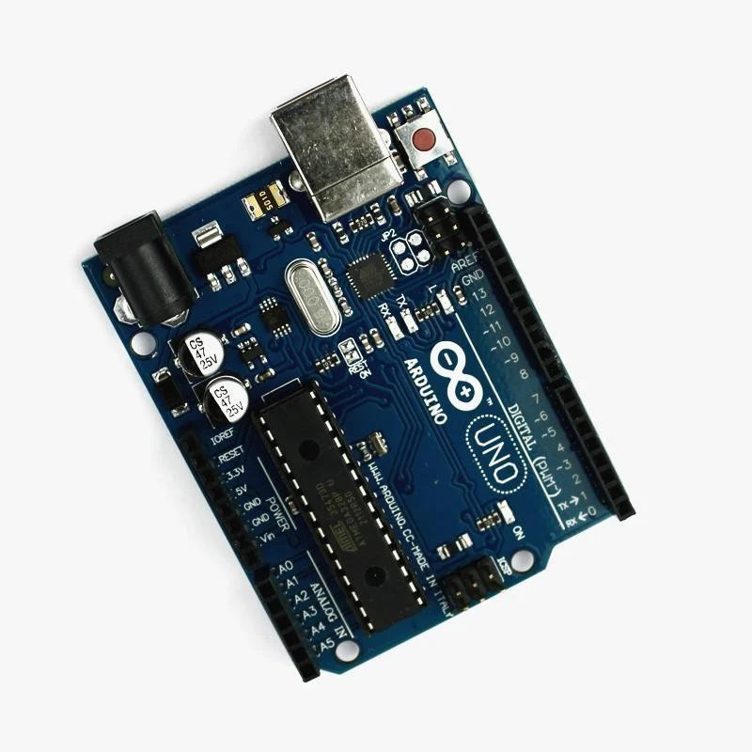

The Arduino Uno board, built around the ATmega328P microcontroller, serves as a versatile tool suitable for both novices and experts in the fields of electronics and programming. Its user-friendly design and adaptability empower users to undertake a broad spectrum of projects, ranging from simple LED blinking exercises to intricate robotics and Internet of Things (IoT) applications.At its core, the Uno board boasts 14 digital input/output pins (including 6 PWM outputs), 6 analog inputs, a USB connection for programming and power supply, a power jack, an ICSP header, and a reset button. Despite its compact size, this board provides a robust foundation for numerous innovations worldwide.A defining trait of the Arduino Uno lies in its open-source nature, facilitating free access to its schematics and software. This openness enables enthusiasts to

customize and enhance its capabilities. Moreover, the vibrant Arduino community continually enriches the platform with libraries, tutorials, and projects, fostering a collaborative and educative atmosphere.Programming the Arduino Uno is made simple through its intuitive Integrated Development Environment (IDE). Employing a streamlined version of C/C++, users can craft code to govern the board's inputs and outputs, interact with sensors, communicate with external devices, and execute various algorithms and logical operations.Thanks to its broad popularity and compatibility with an extensive range of sensors, actuators, and shields, the Arduino Uno serves as an entry point into the realms of electronics and embedded systems. Its affordability and accessibility render it an excellent choice for educational initiatives, do-it-yourself (DIY) projects, prototyping endeavors, and even commercial product development.Beyond its technical specifications, the Arduino Uno embodies a spirit of ingenuity and imagination. It empowers individuals to materialize their concepts into tangible solutions, whether they involve crafting interactive art installations, developing home automation systems, or pioneering the next technological breakthrough.In essence, the Arduino Uno board symbolizes democratized technology, enabling individuals from diverse backgrounds to explore the captivating domains of electronics, programming, and innovation. Its influence transcends its physical components, shaping the way we learn, innovate, and engage with the world around us.

ULTRASONIC SENSOR

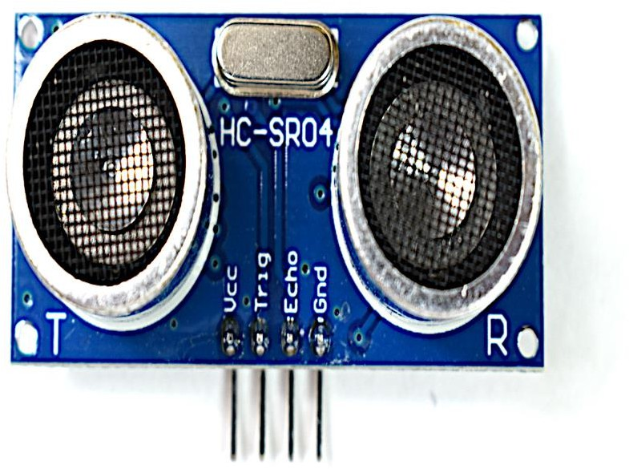

The ultrasonic sensor represents a significant advancement in sensing technology, offering a flexible and effective solution for measuring distances and detecting objects. By utilizing ultrasonic waves, this sensor serves a wide array of purposes, spanning from robotics and industrial automation to healthcare and automotive systems. Its capacity to precisely measure distances and identify objects has established it as an essential tool across various fields.Fundamentally, the ultrasonic sensor functions by emitting high- frequency sound waves and calculating the time taken for these waves to bounce back after encountering an object. Through analyzing this time delay, the sensor determines the distance to the object with remarkable accuracy. This method enables the sensor to operate reliably in diverse environmental conditions, including situations involving light, darkness, dust, and fog.A significant advantage of the ultrasonic sensor lies in its non-contact nature, enabling safe and dependable distance measurement without requiring physical contact with the object under examination. This attribute makes it especially suitable for applications where contact-based methods are impractical or undesirable, such as in medical equipment or hazardous environments.Beyond distance measurement, the ultrasonic sensor's versatility extends to object detection and avoidance. By continuously emitting and receiving ultrasonic waves, the sensor identifies the presence of objects within its range and activates appropriate responses based on predefined criteria. This functionality proves invaluable in robotics, facilitating autonomous navigation and

obstacle avoidance.Moreover, the ultrasonic sensor offers considerable customization and flexibility, allowing users to adjust parameters like detection range, sensitivity, and sampling rate. This adaptability enables users to tailor the sensor's performance to meet the specific demands of their applications, whether they involve precise distance measurement in industrial settings or robust object detection in autonomous vehicles.In addition to its technical capabilities, the ultrasonic sensor boasts a compact and lightweight design, simplifying its integration into various devices and systems. Its low power consumption and cost-effectiveness further contribute to its widespread adoption across industries and applications.The impact of the ultrasonic sensor extends across multiple sectors, driving innovation in areas such as healthcare, automotive safety, and consumer electronics. Its ability to deliver precise distance measurement and reliable object detection has fostered advancements in automation, efficiency, and safety across numerous industries.The ultrasonic sensor serves as a testament to the transformative potential of innovation in sensing technology. Its capacity to accurately measure distances, detect objects, and operate under diverse environmental conditions has positioned it as a vital tool across a broad spectrum of applications. As technology evolves, the ultrasonic sensor is poised to continue playing a pivotal role in shaping the future of automation, robotics, and beyond.

JUMPER WIRE


The jumper wire serves as a crucial element in electronic circuits, functioning as a flexible connection tool that facilitates the smooth transmission of electrical signals among different components. Its basic yet essential design, typically comprising a flexible wire with pins on both ends, simplifies circuit assembly and problem-solving tasks. By bridging connections between various circuit elements like integrated circuits, sensors, and actuators, jumper wires ensure the uninterrupted flow of both data and power, thus enabling the circuit to operate as intended. Additionally, their versatility and flexibility make them invaluable for prototyping, experimentation, and swift modifications in electronic projects. Whether employed to circumvent faulty connections, establish temporary links, or configure intricate circuit setups, jumper wires significantly contribute to enhancing the adaptability and usability of electronic systems. Through their incorporation, engineers, enthusiasts, and educators can engage in exploration and innovation with assurance, recognizing the jumper wire as a dependable and efficient method of interconnecting components in electronic design and development endeavors.

16X2 LCD DISPLAY
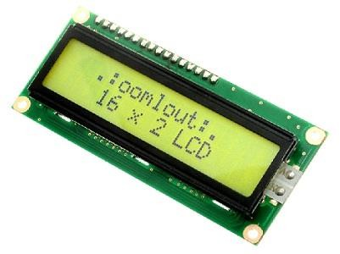

The 16x2 LCD display holds a pivotal role within the electronics domain, functioning as a flexible interface for data visualization and device interaction. Boasting a compact form factor and a crisp screen, it serves as a pragmatic solution for conveying information across a broad spectrum of applications, spanning from everyday consumer gadgets to sophisticated industrial control systems. The numerical designation "16x2" signifies its dimensions, indicating a display featuring 16 characters per line spread across 2 lines.Essentially, the 16x2 LCD display comprises a liquid crystal display (LCD) panel integrated with embedded control circuitry. This circuitry facilitates user communication by transmitting commands and data to the display, thus dictating the content showcased on the screen. Typically employing a parallel interface, the display enables direct communication with microcontrollers and other electronic devices.A prominent feature of the 16x2 LCD display lies in its simplicity and user-friendliness. With a streamlined command structure and

minimal external components required for operation, it offers an accessible solution for incorporating visual feedback into electronic projects. This accessibility renders it a favored choice among hobbyists, students, and professionals alike.Moreover, the versatility of the 16x2 LCD display is further accentuated by its compatibility with an array of microcontrollers and development platforms. Whether interfacing with Arduino, Raspberry Pi, or alternative embedded systems, users can seamlessly integrate the display into their projects with minimal hassle. This interoperability extends its applicability across diverse use cases, ranging from rudimentary temperature displays to intricate user interfaces.In addition to its practicality, the 16x2 LCD display affords users the flexibility to customize visual output according to their preferences. Adjustable parameters such as contrast, brightness, and cursor position empower users to tailor the display to suit their unique requirements. Furthermore, support for diverse character sets and font styles enables users to craft bespoke characters and graphics, enhancing visual aesthetics.
The 16x2 LCD display finds utility across a myriad of sectors, including:
- Consumer Electronics:Featuring in devices like digital clocks, calculators, and household appliances, where it furnishes users with vital information and feedback.
- Industrial Control Systems:Deployed in machinery and automation setups, functioning as a user interface for monitoring equipment status and orchestrating operations.
- Education: Employed in educational endeavors and demonstrations to aid students in understanding electronics, programming, and data visualization concepts.
- Information Displays:Integrated into public transportation systems, vending machines, and information kiosks to deliver pertinent data to users in a lucid and concise manner.
- Prototyping: Utilized in the developmental phase of product creation, enabling engineers and designers to swiftly refine user interfaces and functionalities.In essence, the 16x2 LCD display epitomizes a cornerstone component in electronics, offering a blend of simplicity, adaptability, and utility. Its clear display, user-friendly interface, and cross-platform compatibility render it an indispensable asset for both novices and seasoned professionals. As technological advancements continue to unfold, the 16x2 LCD display remains steadfast as a reliable and indispensable conduit for visualizing data and engaging with electronic devices.

100 RPM MOTOR

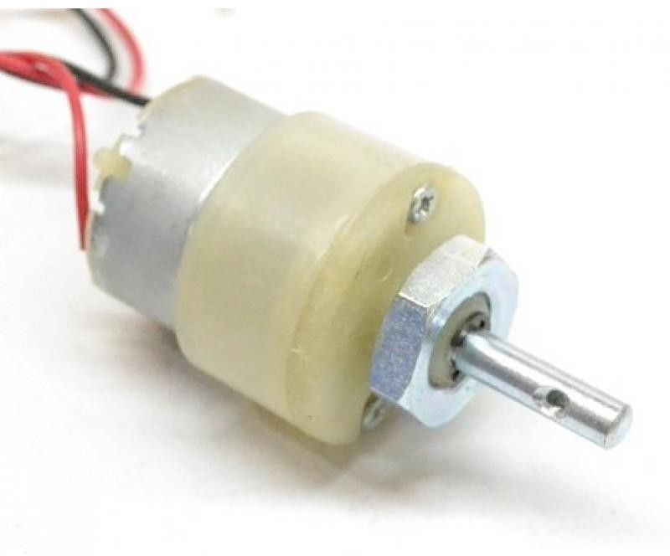

The 100 RPM motor represents a pivotal element in the domain of electromechanical apparatus, offering a flexible and effective mechanism for converting electrical energy into mechanical motion. Operating at a rotational velocity of 100 revolutions per minute, this motor finds extensive utility across a multitude of industries, spanning from robotics and automation to automotive systems and industrial machinery. With its precise speed regulation and sturdy performance, the 100 RPM motor assumes a central role in fostering innovation and energizing vital processes in contemporary society.Fundamentally, the 100 RPM motor comprises several integral components, encompassing a rotor, stator, and commutator, all enclosed within a robust housing. The rotor, typically furnished with permanent magnets or electromagnets, rotates within the stator, housing coils of wire energized by an external power source. The commutator and brushes facilitate the transfer of electrical energy to the rotor, engendering a magnetic field that interacts with the stator to engender rotational movement.
A primary benefit of the 100 RPM motor lies in its capacity to furnish consistent and precise rotational speed, rendering it suitable for applications necessitating controlled motion and positioning. Whether deployed in conveyor systems, turntables, or precision instruments, the motor's steadfast speed output ensures dependable performance and precise operation.
The applications of the 100 RPM motor extend across a diverse array of industries and domains:
- **Robotics:** In robotic systems, the 100 RPM motor furnishes the requisite torque and speed

control for robotic arms, grippers, and actuators, enabling meticulous manipulation of objects and components in manufacturing, assembly, and logistics endeavors.
- **Automation:** Within automated machinery and equipment, the motor propels conveyors, rollers, and rotary actuators, facilitating material handling, sorting, and processing in sectors such as food and beverage, packaging, and automotive manufacturing.
- **Automotive:** In automotive contexts, the 100 RPM motor energizes various components, including windshield wipers, power windows, and seat adjusters, enhancing comfort, convenience, and safety for vehicle occupants.
- **Industrial Machinery:** Within industrial equipment and machinery, the motor propel pumps, fans, and compressors, delivering essential motion control and power transmission in manufacturing, construction, and infrastructure ventures.
- **Home Appliances:** In household appliances like washing machines, dryers, and dishwashers, the motor impels agitators, drums, and pumps, delivering dependable performance and efficient operation for daily chores.Furthermore, the 100 RPM motor incorporates several features to augment its functionality and adaptability, including reversible rotation, variable speed control, and compatibility with various power sources. These attributes empower users to customize the motor's performance to suit precise requirements and seamlessly integrate it into diverse systems and applications.In addition to its technical attributes, the 100 RPM motor boasts a compact and lightweight design, facilitating straightforward installation and integration into existing configurations. Its minimal noise and vibration levels contribute to a conducive and efficient working environment, while its energy-efficient operation curtails power consumption and operating expenses over time.In conclusion, the 100 RPM motor emerges as a foundational element in electromechanical systems, furnishing reliable and precise motion control across a broad spectrum of applications. With its steadfast speed output, robust performance, and versatile features, the motor propels innovation and efficiency across industries, reshaping interactions with technology and energizing indispensable processes in contemporary society. As technological progress continues unabated, the 100 RPM motor is poised to persist as a cornerstone in electromechanical engineering, propelling advancements and innovation for generations to come.

L293D MOTOR DRIVER MODULE

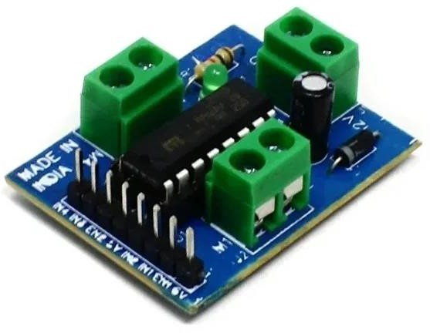

The L293D IC is a highly utilized component designed to manage both the speed and direction of DC motors. Featuring dual H-bridge circuits, it empowers users to control individual motors bidirectionally, enabling rotation in both clockwise and counterclockwise directions while also regulating their speed. This adaptability renders the L293D well-suited for an array of applications spanning robotics, remote-controlled vehicles, and automated systems. Moreover, its inclusive protection mechanisms, such as thermal shutdown and overload safeguards, serve to shield the IC and connected devices from potential harm caused by excessive current or temperature fluctuations. Additionally, its capacity to handle substantial currents further extends its utility, facilitating the control of a diverse range of DC motors, including those employed in compact robotics endeavors and recreational vehicles for hobbyists.

BATTERY



The battery serves as a cornerstone component in numerous modern-day applications, ranging from portable electronics to electric vehicles, owing to its ability to store and deliver electrical energy efficiently. At its core, a battery comprises one or more electrochemical cells that convert stored chemical energy into electrical energy through a controlled chemical reaction. This process allows batteries to provide a reliable and portable power source for various devices and systems. One of the key attributes of batteries is their versatility, as they come in a wide array of sizes, shapes, and chemistries to suit different applications and requirements. From small button cells used in watches and hearing aids to large lithium-ion batteries powering electric vehicles, batteries can be tailored to meet the specific energy needs of diverse devices and industries. Moreover, the rechargeability of many modern batteries further enhances their utility and sustainability. Rechargeable batteries, such as lithium-ion and nickel-metal hydride batteries, can be recharged hundreds or even thousands of times, reducing the need for single-use disposable batteries and minimizing environmental impact. This makes rechargeable batteries an environmentally friendly and cost-effective solution for powering devices ranging from smartphones and laptops to electric cars and renewable energy storage systems.

RF CONTROLLER

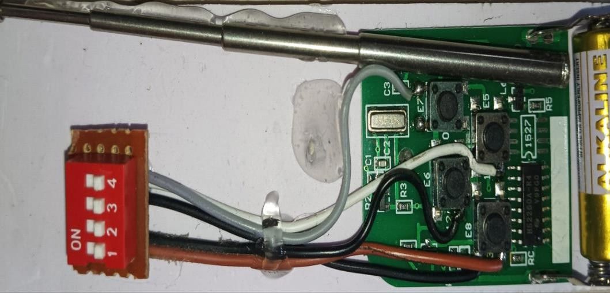

The RF controller, a significant advancement in wireless communication and control systems, provides a flexible and effective means of remotely managing various devices and appliances. Operating on the principle of RF transmission, this controller facilitates seamless interaction with a diverse range of electronic equipment, spanning from home automation devices to industrial machinery. By transmitting signals over considerable distances without physical connections, it fundamentally transforms the way users engage with their surroundings.Essentially, the RF controller comprises two primary components: a transmitter and a receiver. The transmitter emits RF signals encoded with specific commands, while the receiver captures and decodes these signals to execute corresponding actions. This two-way communication empowers users to remotely control devices, adjust settings, and receive feedback without the constraints of wired connections.A notable advantage of the RF controller lies in its adaptability and versatility. With a broad spectrum of operating frequencies and modulation techniques available, users can tailor the configuration to meet their specific needs. This adaptability enables the RF controller to operate effectively across diverse environments, including residential, commercial, and industrial settings.
The applications of the RF controller are manifold across various industries:
- Home Automation: In smart home systems, the RF controller allows users to remotely manage lighting, heating, air conditioning, and security systems from anywhere within range, enhancing convenience, energy efficiency, and security.

- Industrial Control: In manufacturing facilities and industrial plants, the RF controller facilitates remote monitoring and control of machinery, enabling operators to optimize processes, troubleshoot issues, and enhance productivity.
- Automotive:In automotive applications, the RF controller is employed for keyless entry systems, remote engine start, tire pressure monitoring, and vehicle tracking, enhancing convenience, safety, and security for drivers and passengers.
- Healthcare: In medical devices and equipment, the RF controller enables wireless communication between sensors, monitors, and actuators, facilitating remote patient monitoring, telemedicine, and medical device management.
- Entertainment: In entertainment systems, the RF controller is utilized for remote control of televisions, audio systems, gaming consoles, and multimedia devices, enhancing user experience and convenience.Furthermore, the RF controller incorporates robust security features to safeguard communication and prevent unauthorized access. Encryption protocols, authentication mechanisms, and frequency hopping techniques are employed to ensure data integrity and confidentiality, making it suitable for sensitive applications where privacy and security are paramount.In addition to its technical capabilities, the RF controller boasts a compact and lightweight design, facilitating easy integration into existing systems and devices. Its low power consumption and extended battery life further contribute to its appeal, ensuring prolonged operation without frequent maintenance or battery replacement.In summary, the RF controller exemplifies the transformative potential of wireless technology in enabling remote communication and control. Its adaptability, reliability, and security render it an essential tool across a broad spectrum of industries and applications, driving innovation and efficiency in the modern era. As technology continues to evolve, the RF controller will undoubtedly continue to play a pivotal role in shaping the future of wireless communication and control systems.

RF RECEIVER

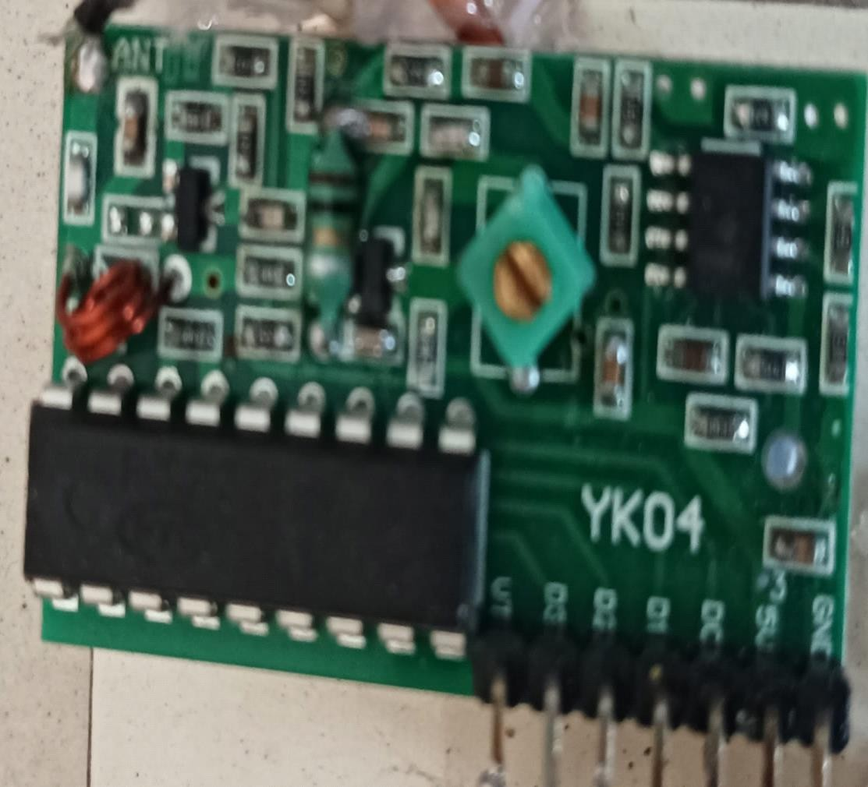

The RF receiver represents a leading-edge technology in wireless communication, acting as an essential component across various electronic systems and devices. As a pivotal element in RF communication, it performs a critical function in capturing and interpreting transmitted signals, facilitating seamless data reception across a broad spectrum of applications. By detecting and processing RF signals emitted by transmitters, the RF receiver enables wireless communication in fields ranging from telecommunications and broadcasting to remote control systems and IoT devices.Functioning on the fundamental principle of receiving electromagnetic waves within the RF spectrum, the RF receiver intercepts these waves carrying encoded information, such as audio,

video, or data signals. These signals are subsequently demodulated and converted into usable form by the receiver, which typically consists of an antenna for signal reception, accompanied by a sequence of amplifiers, filters, and demodulators to extract the original signal from the RF carrier wave.A primary advantage of the RF receiver lies in its flexibility and adaptability to various frequency bands and modulation schemes. By tuning to specific frequencies and deciphering diverse modulation techniques, the receiver can accommodate a broad range of RF signals, making it suitable for an array of applications with differing communication requirements.
The applications of RF receivers span across numerous industries and sectors:
- Wireless Communication: In telecommunications networks, RF receivers are employed in mobile phones, radios, and other wireless devices to receive signals from base stations or other transmitters, facilitating voice calls, text messaging, and data transmission.
- Broadcasting: In radio and television broadcasting, RF receivers capture broadcast signals transmitted over the airwaves, allowing users to tune into radio stations or television channels for entertainment, news, and information.
- Remote Control Systems: In remote control applications, such as garage door openers, remote car locks, and wireless home automation systems, RF receivers receive commands from handheld transmitters, enabling users to remotely control devices and appliances.
- Wireless Sensor Networks:In IoT (Internet of Things) applications, RF receivers are utilized in sensor nodes to gather data from remote sensors and transmit it wirelessly to a central hub or server for monitoring and analysis.
- Navigation Systems:In GPS (Global Positioning System) receivers, RF technology is harnessed to receive signals from satellites orbiting the Earth, empowering users to determine their precise location, speed, and direction.Furthermore, RF receivers are equipped with features to enhance signal reception and mitigate interference, such as automatic gain control (AGC), frequency agility, and signal filtering. These capabilities ensure reliable communication in challenging environments characterized by high levels of noise and interference.In addition to their technical prowess, RF receivers are meticulously designed with considerations for power efficiency, size, and cost-effectiveness, rendering them suitable for integration into a wide array of electronic devices and systems. Their compact form factor and low power consumption make them particularly ideal for battery-powered applications, while their affordability and scalability facilitate mass deployment across consumer electronics, industrial automation, and infrastructure projects.In conclusion, the RF receiver stands as a cornerstone of contemporary wireless communication systems, enabling seamless data reception and transmission across diverse applications and industries. With its adaptability, reliability, and efficiency, the RF receiver plays an indispensable role in shaping the future of wireless connectivity and IoT technology. As advancements in RF technology continue to unfold, the RF receiver is poised to remain at the forefront of innovation, driving progress and connectivity in the digital era.

DOT BOARD


A dot board is typically a perforated or gridded board used for electronic prototyping or circuitry creation. It features a pattern of holes where components can be inserted and connected via wires or solder to construct electrical circuits. These boards are widely used by hobbyists, students, and professionals alike for experimenting with electronics, building prototypes, or designing custom circuits. Dot boards offer versatility and can accommodate different types of components, making them a popular choice for a variety of electronic projects.

CHAPTER-5 SYSTEM DESIGN

  - ARCHITECTURE DIAGRAM
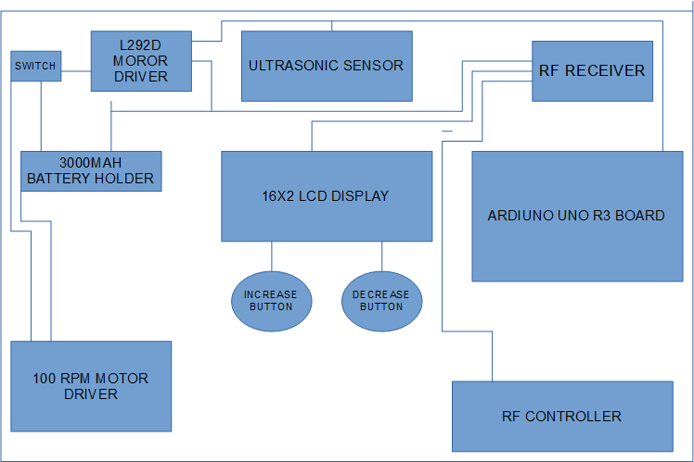

  - FLOW DIAGRAM
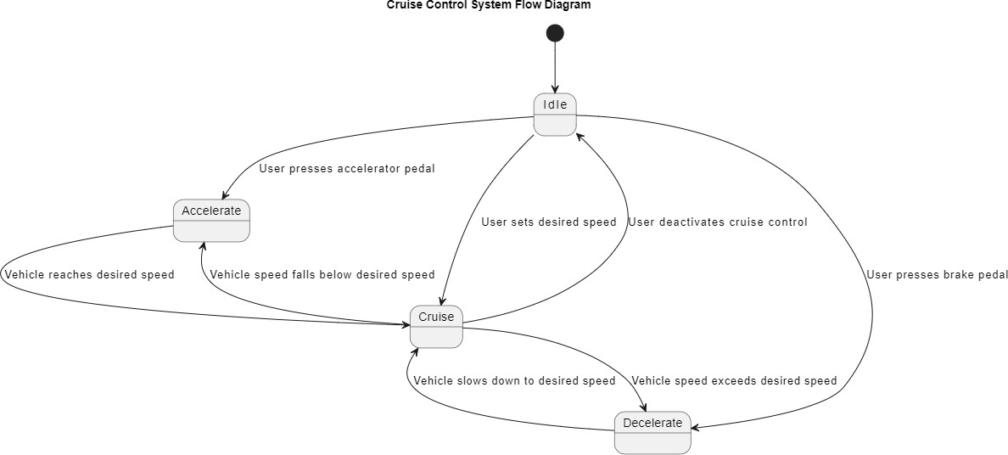

  - USE CASE DIAGRAM

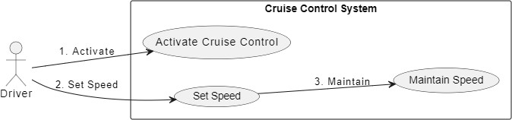

  - CLASS DIAGRAM
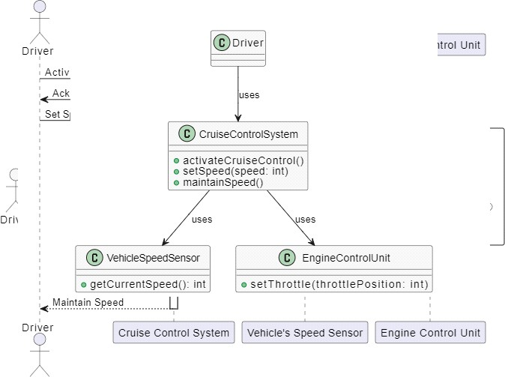

  - SEQUENCE DIAGRAM

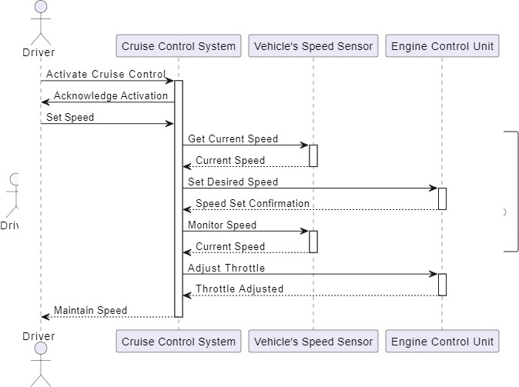

CHAPTER-6 SYSTEM IMPLEMENTATION

  - IMPLEMENTATION
Implementing a cruise control system and ensuring its effectiveness is crucial, instilling confidence in clients regarding its utility. This may involve integrating a new application for a DC motor to replace an existing one, which is typically straightforward if there are no significant changes in the system. Each program undergoes individual testing during development to ensure it operates as specified in the program requirements. Testing involves assessing the DC motor, Arduino, and their overall environment to ensure compatibility with the system's overall design. The generated speed is validated to be suitable for the system's requirements, indicating readiness for cruise control deployment. A straightforward operational procedure is devised to enable cruise speed control over various functions promptly. Initially, the executable version of the application is designed to detect and regulate speed within the typical car system, ensuring compatibility with the entire system and cruise control integration. The final phase involves comprehensive speed detection to manage speed reduction and refine the system's operational approach.

SAMPLE CODING
#define trig_Pin 10
#define echo_Pin 11 int motor_en = 13; int but1 = 2;
int but2 = 3; int but3 = 5; int but4 = 6; int but5 = 7; int but6 = 8;
int but3_state = 0; int but4_state = 0; int but5_state = 0; int but6_state = 0;

int led = 9; int x = 60; int y = 0; int z = 0; int a = 0; int c;
int obc_sw = 12; int obc_state;
int distance;
int ultrasonic_stop = 0; #include <LiquidCrystal.h>

LiquidCrystal lcd(A0, A1, A2, A3, A4, A5); //RS,EN,D4,D5,D6,D7

void setup() { Serial.begin(9600); pinMode(13, OUTPUT); pinMode(9, OUTPUT); pinMode(10, OUTPUT); pinMode(11, INPUT);
pinMode(12, INPUT_PULLUP); pinMode(2, INPUT_PULLUP); pinMode(3, INPUT_PULLUP);
pinMode(5, INPUT); pinMode(6, INPUT); pinMode(7, INPUT); pinMode(8, INPUT);

lcd.begin(16, 2);
lcd.setCursor(0, 0); lcd.print(" WELCOME "); lcd.setCursor(0, 1);
lcd.print("HAVE A GOOD DAY"); delay(2000);
lcd.clear(); delay(100);
digitalWrite(13, LOW);
}

void loop() { if (x <= 60) {
digitalWrite(13, LOW);
}
else if (x > 60) { digitalWrite(13, HIGH);
}
lcd_1(); obstacle();
attachInterrupt(digitalPinToInterrupt(but1), increase, LOW); attachInterrupt(digitalPinToInterrupt(but2), decrease, LOW); delay(100);
c = 0;
capture_speed();
}

void increase() { delay(50);
if (x > 50 && x < 260 && c == 0) { c = 1;
x = x + 20;
y = ((x - 60) / 2); if (x == 80) {
analogWrite(9, 90);
}
else if (x > 250) { analogWrite(9, 255);
}
else if (x != 80) { analogWrite(9, x);
}
return x;
}
else if (x > 260) { x = 260;
}
}

void decrease() { delay(50);
if (x > 60 && x <= 260 && c == 0) { c = 1;

x = x - 20;
analogWrite(9, x); return x;
}
else if (x < 60) { x = 60;
}
}

void lcd_1() {
y = ((x - 60) / 2);
lcd.setCursor(0, 1); if (y != 100) {
lcd.print(y);
}
else if (y == 100) { lcd.print("vehicl speed:"); lcd.print(y);
}
}

void capture_speed() { but3_state = digitalRead(5); but4_state = digitalRead(6); but5_state = digitalRead(7); but6_state = digitalRead(8); if (but3_state == HIGH) {

z = 100;
lcd2();
if (x > z) {
(x = x - 2);
analogWrite(9, x);
}
}
else if (but4_state == HIGH) { z = 140;
lcd2();
if (x > z) {
(x = x - 2);
analogWrite(9, x);
}
}
else if (but5_state == HIGH) { z = 180;
lcd2();
if (x > z) {
(x = x - 2);
analogWrite(9, x);
}
}
else if (but6_state == HIGH) { z = 220;
lcd2();
if (x > z) {

(x = x - 2);
analogWrite(9, x);
}
}
else if (but3_state == LOW && but4_state == LOW && but5_state == LOW && but6_state == LOW) {
lcd.setCursor(0, 0); lcd.print("No cruize Set:");
}
}

void lcd2() { lcd.setCursor(0, 0); lcd.print("cruize limit:"); a = (z - 60) / 2;
lcd.print(a);
}

void obstacle() {
obc_state = digitalRead(12); if (obc_state == HIGH) { read_dist(); delay(50);
if (distance <= 35 && x > 140) {
x = 140; delay(200); analogWrite(9, x); ultrasonic_stop = 4;
}
read_dist(); delay(50);
if (distance <= 25 && x > 120) {

x = 120; delay(200); analogWrite(9, x); ultrasonic_stop = 3;
}
read_dist(); delay(50);
if (distance <= 15 && x > 100) {
x = 100; delay(200); analogWrite(9, x); ultrasonic_stop = 2;
}
read_dist(); delay(50); if (distance <= 5) {
x = 60; delay(200); analogWrite(9, x); ultrasonic_stop = 1;
}
read_dist(); delay(50);
if (ultrasonic_stop == 1 && distance > 5) {
x = z; delay(200); analogWrite(9, x); ultrasonic_stop = 0;
}
delay(50);
if (ultrasonic_stop == 2 && distance > 15) {
x = z; delay(200); analogWrite(9, x); ultrasonic_stop = 0;
}
delay(50);
if (ultrasonic_stop == 3 && distance > 25) {
x = z; delay(200); analogWrite(9, x); ultrasonic_stop = 0;
}
delay(50);
if (ultrasonic_stop == 4 && distance > 35) {
x = z; delay(200); analogWrite(9, x); ultrasonic_stop = 0;
}
}

}

void read_dist() { digitalWrite(trig_Pin, LOW); delayMicroseconds(2); digitalWrite(trig_Pin, HIGH); delayMicroseconds(10); digitalWrite(trig_Pin, LOW);
long duration = pulseIn(echo_Pin, HIGH); distance = duration / 58;
}

output


CHAPTER-7
CONCLUSION AND FUTURE WORK

  - CONCLUSION
The cruise control system stands as a significant leap forward in automotive technology, presenting a multitude of advantages spanning convenience, safety, and efficiency. Throughout our examination, we have thoroughly explored the intricacies and components of cruise control, scrutinizing its development, functionality, benefits, and ramifications. At its essence, the cruise control system streamlines the driving experience by enabling drivers to establish and uphold a consistent speed without constant manual throttle adjustments. This not only alleviates driver fatigue but also amplifies comfort, particularly during extended trips. Furthermore, by fostering a steady driving rhythm, cruise control diminishes unnecessary speed changes, leading to heightened fuel efficiency and decreased environmental impact. A standout attribute of the cruise control system is its role in enhancing road safety. Through speed regulation and the maintenance of a safe following distance from other vehicles, cruise control aids in mitigating accident risks, especially on high-speed roads. Advanced iterations of cruise control, equipped with features like adaptive cruise control and collision avoidance systems, further bolster safety by preemptively adjusting speed and trajectory to avert potential collisions. Moreover, the integration of cruise control with advanced driver assistance systems (ADAS) represents a noteworthy milestone in automotive innovation. By harnessing data from sensors and cameras, cruise control systems can adapt to dynamic road conditions, ensuring optimal performance and safety across diverse driving scenarios. This seamless fusion not only elevates driver convenience but also instills confidence in autonomous driving technologies. The cost-effectiveness and accessibility of cruise control systems render them an appealing choice for a wide demographic. Unlike proprietary alternatives necessitating substantial investments, cruise control harnesses readily available components and open-source technologies, markedly reducing development and deployment costs. This affordability democratizes access to advanced driving assistance technologies, empowering individuals and organizations to enhance their driving experiences affordably. Regarding user interaction, the straightforwardness and clarity of the cruise control system's programming environment play a pivotal role. Engineered with user-friendliness and efficiency in mind, the programming interface facilitates seamless navigation through the system's functionalities. Whether novices or seasoned programmers, users can swiftly grasp the system's programming concepts and tailor their driving experiences to their preferences.

FUTURE WORK ENHANCEMENT
In the domain of cruise control systems, upcoming developments are anticipated to significantly enhance both functionality and safety. A notable avenue for progress involves integrating artificial intelligence (AI) and machine learning algorithms. Through this integration, cruise control systems can become more adaptable and predictive, adjusting vehicle speed not solely based on preset parameters but also considering real-time traffic conditions, road layout, and even driver behavior patterns. This advanced level of sophistication has the potential to result in smoother driving experiences, improved fuel efficiency, and enhanced overall traffic management.In summary, the future of cruise control systems shows significant potential, with advancements in AI integration, connectivity, and energy efficiency poised to transform how vehicles maintain speed and safety on the roads. Embracing these innovations could lead to the evolution of cruise control systems into intelligent, cooperative, and environmentally conscious driving aids, marking a new era in automotive technology.

REFERENCES
    - At the 2013 Conference on Advances in Communication and Control Systems (CAC2S 2013), Husain Ahmed and Gagansingh presented their research on "Fuzzy Logic Controller-Based Control of D.C. Motor."
    - In 2010, Katsuhiko Ogata released the fifth edition of "Modern Control Engineering."
    - In April 2012, M. Saranya and D. Pamela published their work titled "Real-Time IMC Tuned PID Controller for DC Motor" in the International Journal of Recent Technology and Engineering.
    - H. X. Li and S. K. Tso's contribution to "Quantitative Design and Analysis of Fuzzy Proportional- Integral-Derivative Control - Towards Autotuning" appeared in the International Journal of System Science in 2000.
    - Lotfi A. Zadeh introduced "Fuzzy Sets" in the journal Information and Control in 1965.
    - S. Assilian and E. H. Mamdani's experiment on linguistic synthesis using a Fuzzy Logic Controller was published in the International Journal of Man-Machine Studies in 1974.
    - In December 2001, K. Venkateswarlu and Ch. Chengaiah conducted a comparative study on DC motor speed control employing various controllers.
    - Kiam Heong Ang, Gregory Chong, and Yun Li contributed to "PID Control System Analysis, Design, and Technology," published in IEEE Transactions on Control Systems Technology in July 2005.
    - Zhicheng Zhao, Jianggang Zhang, and Mingdong Hou presented an adaptive IMC-PID control scheme based on neural networks at an IEEE conference in 2009.
    - In February 2015, R. G. Longoria delivered lecture notes on "Vehicle Longitudinal Speed Control" at the University of Texas at Austin's Department of Mechanical Engineering.

    - D. McKay, G. Nichols, and B. Schreurs discussed Delphi electronic throttle control systems for model year 2000 in an SAE Technical Paper from 2000.
    - In September 2001, Michael W. Starkweather and James Patrick McKenna patented a "Non- contacting Throttle Valve Position Sensor" (U.S. Patent No. 6,288,534).
    - Shibly Ahmed AL-Samsrraie's work titled "Design of a Continuous Sliding Mode Controller For The Electronic Throttle Valve System" was published in the Journal of Engineering, Iraq, Baghdad University, in 2011.
    - Park, S., & Hedrick, J. K. (2015). A comprehensive analysis of Adaptive Cruise Control Systems: An Overview. In IEEE Transactions on Intelligent Transportation Systems, 17(6), 1457–1469.
    - Kolar, K., & Čelan, S. (2018). An Examination of the Evolution of Adaptive Cruise Control Systems: An Insight. In PROMET-Traffic&Transportation, 30(1), 101–109.
    - Varotto, S., & Savaresi, S. M. (2016). Model-Based Design and Verification of Adaptive Cruise Control Systems for Vehicles. In IEEE Transactions on Control Systems Technology, 24(2), 707–722.
    - Kim, K.-Y., & Yi, K. (2020). A Thorough Survey on Current Research and Developments in Autonomous Vehicle Control Systems. In Sensors, 20(4), 1110.
    - Murgovski, N., Sorniotti, A., Gruber, P., & Onder, C. H. (2018). Optimizing Control Strategies for Automated Vehicles with Adaptive Velocity Setpoints. In IEEE Transactions on Intelligent Transportation Systems, 19(6), 1766–1775.
    - Sun, H., Liu, Z., & Wang, Y. (2019). Development and Design of Cooperative Adaptive Cruise Control Systems for Connected and Automated Vehicles. In IEEE Access, 7, 177201–177212.
    - Guanetti, J., Dib, A., Gruyer, D., & Glaser, S. (2019). A Comprehensive Review of Cooperative Adaptive Cruise Control: Insights from Literature and Practical Applications. In IEEE Transactions on Intelligent Transportation Systems, 20(3), 1028–1047.

